MISY 3322 – Systems Analysis and Design
Group Project Report
WaveTrip
Online Boat Booking & Fishing Trip Platform
Prepared By:
Khalid Alkhalawi
Turki Alotaibi
Submitted to: Dr. Samer Al-Imamy
Course: MISY 3322 – Systems Analysis and Design
Deadline: May 20, 2026

WaveTrip
Online Boat Booking & Fishing Trip Platform
Executive Summary
WaveTrip is an online boat booking and fishing trip platform developed as a group project by Khalid Alkhalawi and Turki Alotaibi for MISY 3322 – Systems Analysis and Design. The platform addresses a clear gap in the Saudi Arabian market: fishing enthusiasts and recreational boaters currently have no centralized website where they can browse, compare, and book boats. Instead, they rely on social media posts, word of mouth, or direct phone calls, with no way to verify pricing, availability, or quality. WaveTrip resolves this by creating a transparent marketplace where multiple boat listings can be viewed side by side, each with photos, available time slots, and package prices.
To enrich the booking experience, WaveTrip includes an optional bundle feature allowing customers to add extra activities at the time of reservation. Payment flexibility is achieved through two supported methods: online payment via Visa or pay on arrival, giving customers freedom of choice. A post-trip review and rating system enables customers to leave written feedback and star ratings after each completed trip, which accumulates into an aggregate score displayed on each boat owner's profile — building trust across the platform. The system serves two distinct user types, customers and boat owners, through a single website with separate registration flows, avoiding the cost and complexity of two separate platforms. The complete system including a functional prototype is targeted for delivery by May 20, 2026.

Request for System Services (RISS)
Field | Details
Project Name | WaveTrip – Online Boat Booking Platform
Requested By | Ahmad Al-Harbi (Fictional Client)
Date | January 15, 2026
Problem | Customers cannot easily browse multiple boat options for fishing trips. There is no centralized platform to compare boats, pricing, and availability in one place.
Opportunity | The fishing tourism market is growing. A digital platform would allow boat owners to increase bookings and customers to enjoy a convenient, transparent booking experience.
Expected Solution | A web-based marketplace where customers can browse boats with photos and pricing, select optional activity bundles, choose a payment method (online Visa or pay on arrival), and leave post-trip reviews. Boat owners and customers share a single platform with different account types.
Priority | High – Deadline: May 20, 2026
Authorized By | Ahmad Al-Harbi

Problem Statement Matrix
Problem | Proposed Solution
Limited Visibility: Customers want to see more than one boat option for their trips. | Provide a marketplace interface where multiple boats are displayed with pictures and pricing.
Rigid Activity Options: Customers may want more than just a basic trip. | Implement an optional bundle feature for extra activities during the trip.
Payment Inconvenience: Need for flexible payment methods beyond just cash. | Integrate dual payment options: Online Visa or Pay on Arrival.
Account Complexity: The client needs a system for both owners and users without the cost of two separate sites. | Develop a single website with two distinct sign-up/login types (User vs. Boat Owner).
Lack of Trust: Users need a way to verify the quality of a boat or owner. | Build a review and rating system where user feedback directly impacts owner profiles.

Problem Analysis
B. Problem Analysis Interview (Appendix B)
A follow-up interview was conducted to refine and expand on the requirements gathered during the preliminary investigation.
Analyst: Can you describe the main frustrations customers face today when trying to book a fishing trip?
Customer: They mostly rely on word of mouth or social media to find a boat. There is no single place to compare options, prices, or availability.
Analyst: What information does a customer need to make a booking decision?
Customer: Photos of the boat, the available time slots, and the price list for each package or bundle.
Analyst: Are there any constraints we should be aware of?
Customer: Budget is a concern. We cannot afford two separate websites. Everything must be on one platform. Also, the system should be simple enough for boat owners who are not tech-savvy.
Analyst: What are the most important outcomes for you?
Customer: Trust and convenience. Customers should trust the platform through reviews and ratings, and booking should take no more than a few clicks.

Problems, Opportunities, Objectives, and Constraints (POOC) Matrix
Problems | Opportunities | Objectives | Constraints
No single platform to compare multiple boats | Growing demand for fishing tourism experiences | Provide a marketplace showing multiple boat listings | Single website; no separate platform for owners
Limited payment flexibility (cash only) | Increase online payment adoption | Offer Visa and pay-on-arrival payment options | Budget constraints limit system complexity
Lack of trust and transparency in trip quality | Build customer loyalty through transparency | Implement a review and rating system per boat owner | Boat owners may have low technical literacy
Limited activity options beyond basic trips | Upsell additional activities to boost revenue | Add optional activity bundles at booking time | Delivery deadline: May 20, 2026

List of Requirements
Functional Requirements
- FR1 – User Registration: The system shall allow customers and boat owners to register using separate account types on the same website.
- FR2 – Boat Listings: Boat owners shall be able to list their boats with photos, available time slots, and package prices.
- FR3 – Boat Browsing: Customers shall be able to browse and compare multiple boat listings.
- FR4 – Booking: Customers shall be able to select a boat, choose a time slot, and confirm a booking.
- FR5 – Optional Bundles: Customers shall be able to add optional activity bundles to their booking.
- FR6 – Payment: The system shall support two payment methods: online Visa payment and pay on arrival.
- FR7 – Reviews and Ratings: After a completed trip, customers shall be able to leave a review and star rating for the boat owner.
- FR8 – Owner Rating Display: Each boat owner's profile shall display an aggregate rating based on customer reviews.
- FR9 – Booking History: Users shall be able to view their past and upcoming bookings.
- FR10 – Boat Management: Boat owners shall be able to add, edit, or remove their boat listings.

Non-Functional Requirements
- NFR1 – Usability: The interface shall be simple enough for non-technical boat owners to use without training.
- NFR2 – Performance: The website shall load boat listings within 3 seconds under normal network conditions.
- NFR3 – Security: User passwords shall be stored using hashing. Payment data shall be handled via a secure payment gateway.
- NFR4 – Availability: The system shall be available 99% of the time, excluding scheduled maintenance.
- NFR5 – Scalability: The system shall be designed to support an increasing number of boat listings and users over time.
- NFR6 – Compatibility: The website shall function correctly on modern browsers (Chrome, Firefox, Edge, Safari) and be mobile-responsive.

Modeling Functional Requirements
Use-Case Glossary
Use Case | Description | Actors
UC1 – Register Account | A new user or boat owner creates an account on WaveTrip by selecting their account type and providing registration details. | Customer, Boat Owner
UC2 – Login | A registered user logs into the system using their credentials. | Customer, Boat Owner
UC3 – Browse Boats | A customer views available boat listings, filters by date and price, and compares options. | Customer
UC4 – Book a Boat | A customer selects a boat, chooses a time slot and optional bundles, and confirms the booking. | Customer
UC5 – Select Payment Method | During checkout, the customer selects either online Visa payment or pay on arrival. | Customer
UC6 – Leave Review | After a completed trip, a customer submits a rating (1–5 stars) and a written review for the boat owner. | Customer
UC7 – Manage Listing | A boat owner adds a new boat listing, uploads photos, sets pricing, and defines available time slots. | Boat Owner
UC8 – View Bookings | Users can view upcoming and past bookings. Boat owners see all reservations on their boats. | Customer, Boat Owner
UC9 – View Ratings | Any user can view the aggregate rating and individual reviews on a boat owner's profile page. | Customer, Boat Owner
UC10 – Manage Profile | A registered user updates their personal information, password, or profile picture. | Customer, Boat Owner

Use-Case Model Diagram
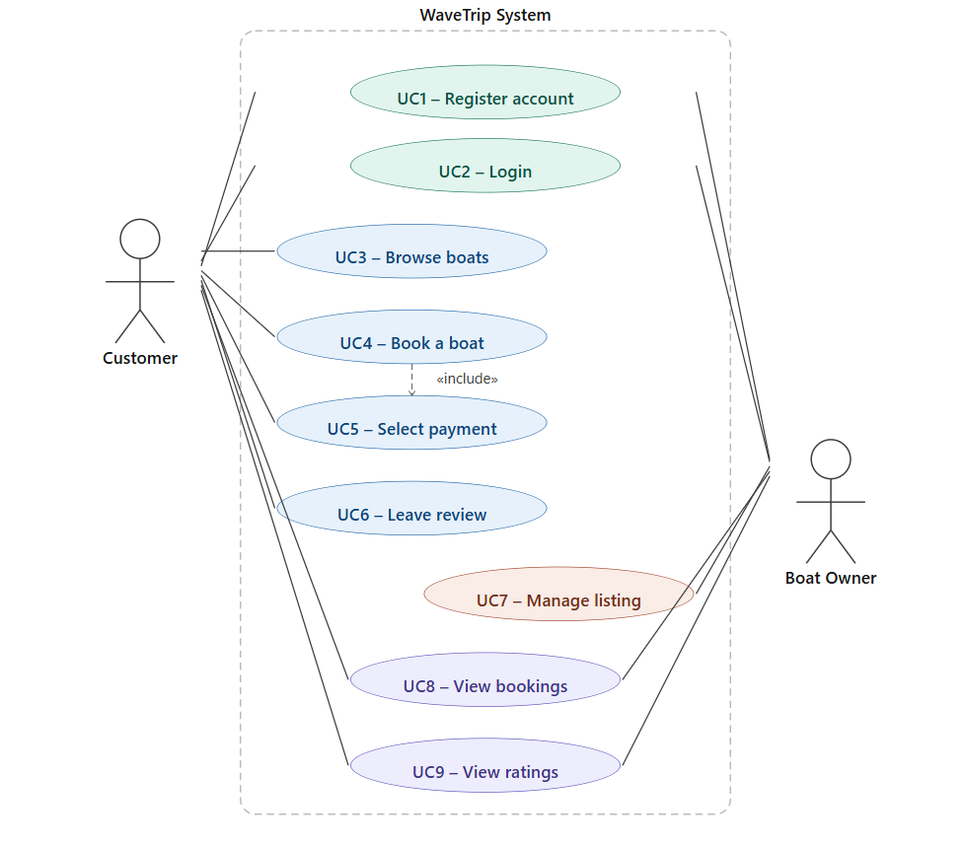
Use-Case Narratives
UC4 – Book a Boat
Field | Details
Use Case Name | Book a Boat
Actor(s) | Customer
Preconditions | The customer is logged in. At least one boat listing is available for the selected date.
Main Flow | 1. Customer browses boat listings and selects a boat.  2. Customer chooses an available time slot.  3. System displays optional activity bundles.  4. Customer selects desired bundles or skips.  5. System shows booking summary with total price.  6. Customer confirms booking and proceeds to payment (UC5).  7. System records the booking and sends a confirmation.
Alternate Flow | If no time slots are available, the system notifies the customer and suggests alternative dates.
Postconditions | A booking record is created. The boat owner is notified of the new reservation.
Priority | High

UC6 – Leave a Review
Field | Details
Use Case Name | Leave a Review
Actor(s) | Customer
Preconditions | The customer is logged in and the trip has been marked as completed.
Main Flow | 1. Customer navigates to their booking history.  2. Customer selects a completed trip.  3. System presents a review form with a star rating (1–5) and a text field.  4. Customer submits the review.  5. System saves the review and updates the boat owner's aggregate rating.
Alternate Flow | If the customer has already submitted a review for this trip, the system displays the existing review and offers an edit option.
Postconditions | The review is visible on the boat owner's profile. The owner's overall rating is recalculated.
Priority | Medium

UC7 – Manage Listing
Field | Details
Use Case Name | Manage Listing
Actor(s) | Boat Owner
Preconditions | The boat owner is logged in with a Boat Owner account type.
Main Flow | 1. Boat owner navigates to My Listings.  2. Owner selects Add New Boat.  3. System presents a form: boat name, photos, description, capacity, available time slots, and pricing per package.  4. Owner completes and submits the form.  5. System validates the data and publishes the listing.
Alternate Flow | Owner may select an existing listing to edit or deactivate it without deleting the booking history.
Postconditions | The new or updated boat listing is visible to customers on the platform.
Priority | High

UC1 – Register Account
Field | Details
Use Case Name | Register Account
Actor(s) | Customer, Boat Owner
Preconditions | The user is not already registered. The WaveTrip website is accessible.
Main Flow | 1. User navigates to the WaveTrip registration page. 2. User selects account type: Customer or Boat Owner. 3. System displays the appropriate registration form. 4. User fills in required fields: name, email, password, and phone number. 5. User submits the form. 6. System validates the input and checks that the email is not already in use. 7. System creates the account and sends a confirmation message. 8. User is redirected to the login page.
Alternate Flow | If the email address is already registered, the system displays an error message and prompts the user to log in or use a different email.
Postconditions | A new account is created and stored in the system. The user can now log in and access features appropriate to their account type.
Priority | High

UC3 – Browse Boats
Field | Details
Use Case Name | Browse Boats
Actor(s) | Customer
Preconditions | At least one boat listing exists in the system. The WaveTrip website is accessible.
Main Flow | 1. Customer navigates to the boat listings page. 2. System displays all available boat listings with photos, names, capacity, and starting prices. 3. Customer optionally applies filters (date, price range, or boat type). 4. System refreshes the listings to match the selected filters. 5. Customer clicks on a boat card to view full details including time slots, packages, and owner rating. 6. Customer may proceed to book the selected boat (UC4) or return to the listings.
Alternate Flow | If no listings match the applied filters, the system displays a “No results found” message and suggests clearing the filters or adjusting the selected date range.
Postconditions | The customer has viewed one or more boat listings and can either proceed to booking or exit the page. No data is modified.
Priority | High

Modeling Object Requirements
Entity / Definition Matrix
Entity | Definition | Key Attributes
User | Any registered person on the platform. Can be a Customer or a Boat Owner. | userID, name, email, password, accountType
Customer | A User who browses listings and books fishing trips. | customerID, phone, bookingHistory
Boat Owner | A User who registers and manages boat listings on the platform. | ownerID, bankDetails, overallRating
Boat | A vessel listed by a Boat Owner. Customers can browse and book it. | boatID, name, photos, capacity, description, ownerID
TimeSlot | A specific date and time window during which a boat is available for booking. | slotID, boatID, date, startTime, endTime, isAvailable
Package | A pricing tier or activity bundle offered by a boat owner for a trip. | packageID, name, description, price, boatID
Booking | A confirmed reservation made by a Customer for a specific Boat and TimeSlot. | bookingID, customerID, boatID, slotID, packageID, status, totalPrice
Payment | A transaction associated with a Booking. Supports Visa or pay-on-arrival. | paymentID, bookingID, method, amount, status, date
Review | Feedback submitted by a Customer after a completed trip. | reviewID, customerID, ownerID, bookingID, rating, comment, date

Domain Model Diagram
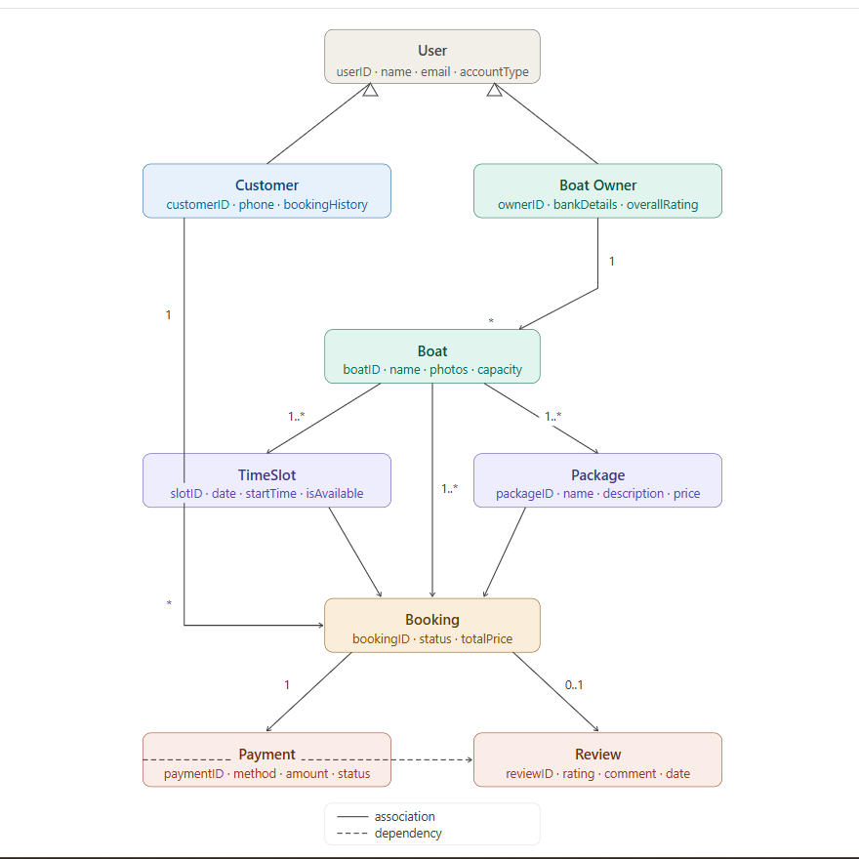
Use-Case Ranking
Use cases are evaluated on a 1–5 scale across six criteria: architectural impact, functionality, risk/complexity, new technology, business value, and revenue impact.
Use Case | Arch. Impact | Functionality | Risk / Complexity | New Technology | Business Value | Revenue Impact | Total (/30)
UC4 – Book a Boat | 5 | 5 | 4 | 3 | 5 | 5 | 27
UC5 – Select Payment | 4 | 4 | 5 | 4 | 4 | 5 | 26
UC7 – Manage Listing | 5 | 5 | 3 | 2 | 5 | 5 | 25
UC1 – Register Account | 5 | 4 | 3 | 2 | 5 | 4 | 23
UC3 – Browse Boats | 4 | 4 | 3 | 3 | 4 | 4 | 22
UC6 – Leave Review | 3 | 4 | 2 | 2 | 5 | 4 | 20
UC9 – View Ratings | 2 | 3 | 1 | 1 | 4 | 3 | 14
UC8 – View Bookings | 2 | 3 | 2 | 1 | 3 | 2 | 13
UC2 – Login | 3 | 2 | 2 | 1 | 3 | 2 | 13
UC10 – Manage Profile | 2 | 2 | 1 | 1 | 2 | 1 | 9

Project Management
Gantt Chart – WaveTrip Project Plan
Task | Assigned To | Duration | Start Date | End Date
Project Kickoff and Idea Selection | Both | 3 days | Jan 15, 2026 | Jan 17, 2026
Preliminary Investigation and Interview A | Both | 4 days | Jan 18, 2026 | Jan 21, 2026
Problem Analysis and Interview B | Both | 4 days | Jan 22, 2026 | Jan 25, 2026
Requirements List (Functional and Non-Functional) | Khalid | 3 days | Jan 26, 2026 | Jan 28, 2026
Use-Case Glossary and Diagram | Turki | 5 days | Jan 29, 2026 | Feb 02, 2026
Use-Case Narratives (3 narratives) | Both | 5 days | Feb 03, 2026 | Feb 07, 2026
Entity/Definition Matrix | Khalid | 3 days | Feb 08, 2026 | Feb 10, 2026
Domain Model Diagram | Turki | 4 days | Feb 11, 2026 | Feb 14, 2026
Prototype Development (UI and Core Features) | Both | 50 days | Feb 15, 2026 | Apr 05, 2026
Prototype Testing and Refinement | Both | 14 days | Apr 06, 2026 | Apr 19, 2026
Report Finalization and Review | Both | 14 days | Apr 20, 2026 | May 03, 2026
Screencast Demo Recording | Both | 7 days | May 04, 2026 | May 10, 2026
Final Submission | Both | 1 day | May 20, 2026 | May 20, 2026

Scope Definition
A. Preliminary Investigation Interview (Appendix A)
The following interview was conducted between the customer (stakeholder) and the developer to gather the initial system requirements.
Customer: I want a system that I can book a boat and go fishing and I can see more than one boat.
Developer: Okay, what about other activities — I can make an optional bundle. Is that okay?
Customer: Yes please, and can you make the payment through the website?
Developer: Yes, I can make 2 types of payment method: pay on arrival or online Visa — it will be optional.
Customer: And I want you to show a picture of the boat and the available time that I can book and the price for each bundle.
Developer: Yes, I can make that.
Customer: And I want two types of account, one for the user that wants to book a boat and one for the boat owner that can sign up his boat.
Developer: Sure. Do you want me to make a separate website for the boat owner to sign his boat?
Customer: No, that will cost more. I don't want that — make it 2 types of sign-up, one for the user and one for the boat owner on the same website.
Developer: Okay, I will do that.
Customer: Can you add an option for the user that lets them leave a review and a rating for the trip?
Developer: Yes, I can make that, and each boat owner can have a rating based on the users' reviews.
Customer: Yes, that will be great.
Developer: Okay, when is the deadline?
Customer: It will be on 2026/05/20.
Developer: Okay, if you need anything, ask me — I will be in touch with you.
Customer: Ok, thank you.

